

[Artificia](https://doi.org/10.1016/j.ailsci.2021.100021)l[IntelligenceintheLifeSciences1(2021)100021](https://doi.org/10.1016/j.ailsci.2021.100021)

|  |  |  |
| --- | --- | --- |
|  | Contentslistsavailableat[ScienceDirect](http://www.ScienceDirect.com) |  |
| ArtificialIntelligenceintheLifeSciences |
| journalhomepage:[www.elsevier.com/locate/ailsci](http://www.elsevier.com/locate/ailsci) |

ResearchArticle

Dealingwithadata-limitedregime:Combiningtransferlearningand transformerattentionmechanismtoincreaseaqueoussolubilityprediction performance

MagdalenaWierciocha,b,∗,JohannesKirchmairb

a*DepartmentofAppliedComputerScience,FacultyofPhysics,AstronomyandAppliedComputerScience,JagiellonianUniversity,Łojasiewicza11,Kraków30-348,*

*Poland*

b*DepartmentofPharmaceuticalChemistry,FacultyofLifeSciences,UniversityofVienna,Vienna1090,Austria*

|  |  |  |
| --- | --- | --- |
| article | info | abstract |
| *Keywords:*  Aqueoussolubility DeepLearning  Cheminformatics  Transformermodel Drugdiscovery  Regression |  | Aqueoussolubilityisakeychemicalpropertythatdrivesvariousprocessesinchemistryandbiology.Itscom-putationalpredictionischallenging,asevidencedbythefactthatithasbeenasubjectofconsiderableinterest forseveraldecades.Recentworkhasexploredfingerprint-based,feature-basedandgraph-basedrepresentations withdifferentmachinelearninganddeeplearningmethodologies.Ingeneral,manytraditionalmethodshave beenproposed,buttheyrelyheavilyonthequalityoftherule-based,hand-craftedfeatures.Ontheotherhand, limitationsinthequalityofaqueoussolubilitydatabecomeahandicapwhentrainingdeepmodels.Inthisstudy, wehavedevelopedanovelstructure-awaremethodforthepredictionofaqueoussolubilitybyintroducinga newdeepnetworkarchitectureandthenemployingatransferlearningapproach.Themodelwasproventobe competitive,obtaininganRMSEof0.587duringbothcross-validationandatestonanindependentdataset.To bemoreprecise,themethodisevaluatedonmoleculesdownloadedfromtheOnlineChemicalDatabaseand ModelingEnvironment(OCHEM).Beyondaqueoussolubilityprediction,thestrategypresentedinthisworkmay beusefulformodelinganykindof(chemicalorbiological)propertiesforwhichthereisalimitedamountofdata availableformodeltraining. |

**1.Introduction**

Significantprogresshasbeenmadeinthepredictionofquantitative structure-propertyrelationships(QSPRs)forsmallorganicmolecules, inparticularinmachinelearning[1].Inthecontextofsmall-molecule drugdiscoveryandthedevelopmentofagrochemicals,cosmetics,func-tionalfoods,etc.,aqueoussolubilityhasbeenafieldofactiveresearch forseveraldecadesnowasitdetermines,amongmanyotherthings,a compound’sabilitytocrossthebiologicalmembranesand,hence,itsca-pacitytoinducedesiredbiologicaleffects(e.g.inthecontextofpharma-cology)and/orundesiredbiologicaleffects(inthecontextoftoxicology) inorganisms.Thedevelopmentofhighlyefficacioussmall-molecules thataresufficientlysolubleinwaterremainsachallengingtaskbecause aqueoussolubilityandbiologicalactivityareoftenobservedtobeinan indirectproportionalrelationship[2].

Aqueoussolubilityisusuallyreportedaslog*𝑆*,thelogarithmofbase 10oftheaqueoussolubilityinmol/L.However,aqueoussolubilityis notaneasymolecularpropertytomeasureaccurately,forwhichrea-

sonvariousapproachesformeasuringitareinexistenceanduse.Data qualityvariessubstantiallybetweendifferentdatasources,andresults obtainedwithdifferenttechnologiesarenotalwayscomparable.Thisis thereasonwhywecaninpartobserveonlyamoderatereproducibil-ityofaqueoussolubilitymeasurements.Onthewhole,therearevaried sourcesofdata,andtheexactinformationconnectedwithaqueoussol-ubilitymethodologyisnotalwaysgiven[3].Inconsequence,thelack ofhigh-qualitydatasetsforcomputationalaqueoussolubilityprediction isproblematic[4,5].Pleasenotethatthereportedpredictionrootmean squareerrors(RMSE)ranges0.6–1.4log,withtheaverageat0.9log[6]. Classicalmachinelearningtechniqueshavedemonstratedremark-ableperformanceinQSPRmodeling,includingaqueoussolubilitypre-diction.Generally,classicalmachinelearningapproachescanbesplit intotwostages.Thefirststageaimstoencodetheinputdataandextract themostimportantfeaturesorpropertiesconnectedwiththemolecule. Inconsequence,onegetsamolecularrepresentation.Thesecondstage usuallyappliesanalgorithmthattakesacalculatedmolecularrepresen-tationasaninputandreturnssomeresponse.Inaddition,whilebuilding

∗Correspondingauthorat:DepartmentofAppliedComputerScience,FacultyofPhysics,AstronomyandAppliedComputerScience,JagiellonianUniversity, Łojasiewicza11,30-[348Kraków,Poland.](mailto:magdalena.wiercioch@uj.edu.pl)

*E-mailaddresses:*[magdalena.wiercioch@uj.edu.pl](mailto:magdalena.wiercioch@uj.edu.pl),[mgkwiercioch@gmail.com](mailto:mgkwiercioch@gmail.com)(M.Wiercioch),[johannes.kirchmair@univie.ac.at](mailto:johannes.kirchmair@univie.ac.at)(J.Kirchmair).

<https://doi.org/10.1016/j.ailsci.2021.100021>  
[Received4October2021;Receivedinrevised](https://doi.org/10.1016/j.ailsci.2021.100021)form20November2021;Accepted23November2021   
Availableonline26November2021   
[2667-3185/© 2021TheAuthors.PublishedbyElsevi](http://creativecommons.org/licenses/by-nc-nd/4.0/)erB.V.ThisisanopenaccessarticleundertheCCBY-NC-NDlicense (<http://creativecommons.org/licenses/by-nc-nd/4.0/>)

*M.WierciochandJ.Kirchmair*

machinelearningmodels,oneusesthetrain-testsplitasamethodfor evaluatingtheperformanceofamachinelearningalgorithm.

Toaddresstheproblemofaqueoussolubilityprediction,several methodshavebeenproposed[7,8].Thefirsttechniqueappearedin1924 inworkbyFühner[9].Fühnerobservedthattheadditionofsuccessive methylenegroupscausesadecreaseofaqueoussolubility.Subsequently, scientistsdiscoveredthatvariousmolecularfeaturesaffectaqueoussolu-bility[10–12].Overtheyears,differentmodelswereapplied.Erickson usedlinearregressiontoinvestigatetheaqueoussolubilityofhomol-ogousseriesoforganicmolecules[13].Heobservedthatlog*𝑆* wasa negativerectilinearfunctionofalkylchainlengthofhomologousseries. Later,Hewittetal.analyzedmultilinearregressionsperformancetopre-dictaqueoussolubility[14].Theirconclusionsweresurprisingsincea simplelinearregressionapproachprovedtobesuperiorovermorecom-plexmodelingmethodsatthattime.Theauthorsnoticedthatthestatis-ticalfitofthetrainingandvalidationdatawasreasonablygood(*𝑅*2val-uesof0.74and0.67,respectively).Finally,therootmeansquareerror (RMSE)valueforthetestsetof0.95wasobtained.WithRandomForest, Palmeretal.studiedthepredictionofaqueoussolubilityforadatasetof compoundsthataresolidatroomtemperature[15].Theirmethodhas beenshowntoperformcomparablytoothermethods,includingsome thatrequire3Dstructurecalculation.Tospecify,theauthorspredicted thelogmolarsolubilityvaluesforthemoleculesinthetestsetwith RMSEof0.69.Also,LindandMaltsevahavedemonstratedthatSup-portVectorMachineswithaTanimotosimilaritykerneldetectsaque-oussolubilitywithaccuracy,expressedintermsofrootmeansquare error,producecomparableresultsthanotherreportedapproaches[16]. Theyreportedthatthecross-validationonadiversedatasetresulted inaRMSEof0.62and*𝑅*2of0.88.Besides,artificialneuralnetworks havebeenutilizedtopredictaqueoussolubility[17].Thegoalwasto takeadvantageoftheirabilitytoapproximatenon-linearfunctions.For instance,Erić etal.proposedamethodologyfortheautomaticadjust-mentofdescriptor’srelativeimportanceincounter-propagationshallow neuralnetworksinordertopredictaqueoussolubility[18].Theperfor-manceoftheirfinalmodelbasedonsevendescriptorsforpredictionof aqueoussolubilitywassatisfactorysincetheauthorsreportedanRMSE of0.679ontestdataset.

Veryrecently,deepneuralnetworks(DNNs)[19–21]haveyielded impressiveperformanceinmolecularandothermaterialspropertypre-diction[22–25].Whiletheclassicalmachinelearningapproachesre-quirehand-craftedmoleculardescriptorsasinputs,DNNscanemploy morelosslessformatsandtrainmodelsinanend-to-endfashioninorder topredictthetargetendpoints.Besides,therearemanydifferentformats ofinputrepresentation[26].Thestandardtypeisatopologicalgraph thatdescribestheconnectivityoftheatoms.AnotherexampleisSMILES strings(SimplifiedMolecularInputLineEntrySystem).Broadlyspeak-ing,SMILESisatext-basedformatwherechemicalspeciesaremapped tosingleASCIIstrings[27].

Deeplearningsystemshaveimprovedthestate-of-the-artinaque-oussolubilityprediction.Forinstance,Luscietal.proposedanarchi-tecturethatusesarecurrentneuralnetworkandmolecularstructures convertedintodirected,acyclicgraphs.Theirmethodology,calledUG-RNN,sometimesoutperformedcurrentthenstate-of-the-arttechniques [28].Forinstance,UG-RNNachievesRMSEof0.96ontheintrinsicsol-ubilitydataset.AnotherexampleistheworkofWuetal.,wherethe authorsconstructedatopology-basedmulti-taskdeeplearningstrategy (MT-DNN)andachievedsomeofthemostaccuratepredictionsofaque-oussolubility(RMSEof0.649)andthepartitioncoefficient[29].Also, Liuetal.presentedacompetitiveapproach(Chemi-Net)basedonconvo-lutionalneuralnetworkstopredictaqueoussolubilityandotherADME properties[30].TheydemonstratedthatChemi-Netbeatsthecompet-itivemodelsandachievesan*𝑅*2of0.585.Finally,in2020Tangetal. [31]proposedaself-attention-basedmessagepassingneuralnetwork toidentifytherelationshipbetweenmolecularsolubilityandstructure. TheirmethodobtainedanRMSEof0.661(foraqueoussolubilitypre-diction)onasmallcollectionofcompounds.

2

*M.WierciochandJ.Kirchmair*  *ArtificialIntelligenceintheLifeSciences1(2021)100021*

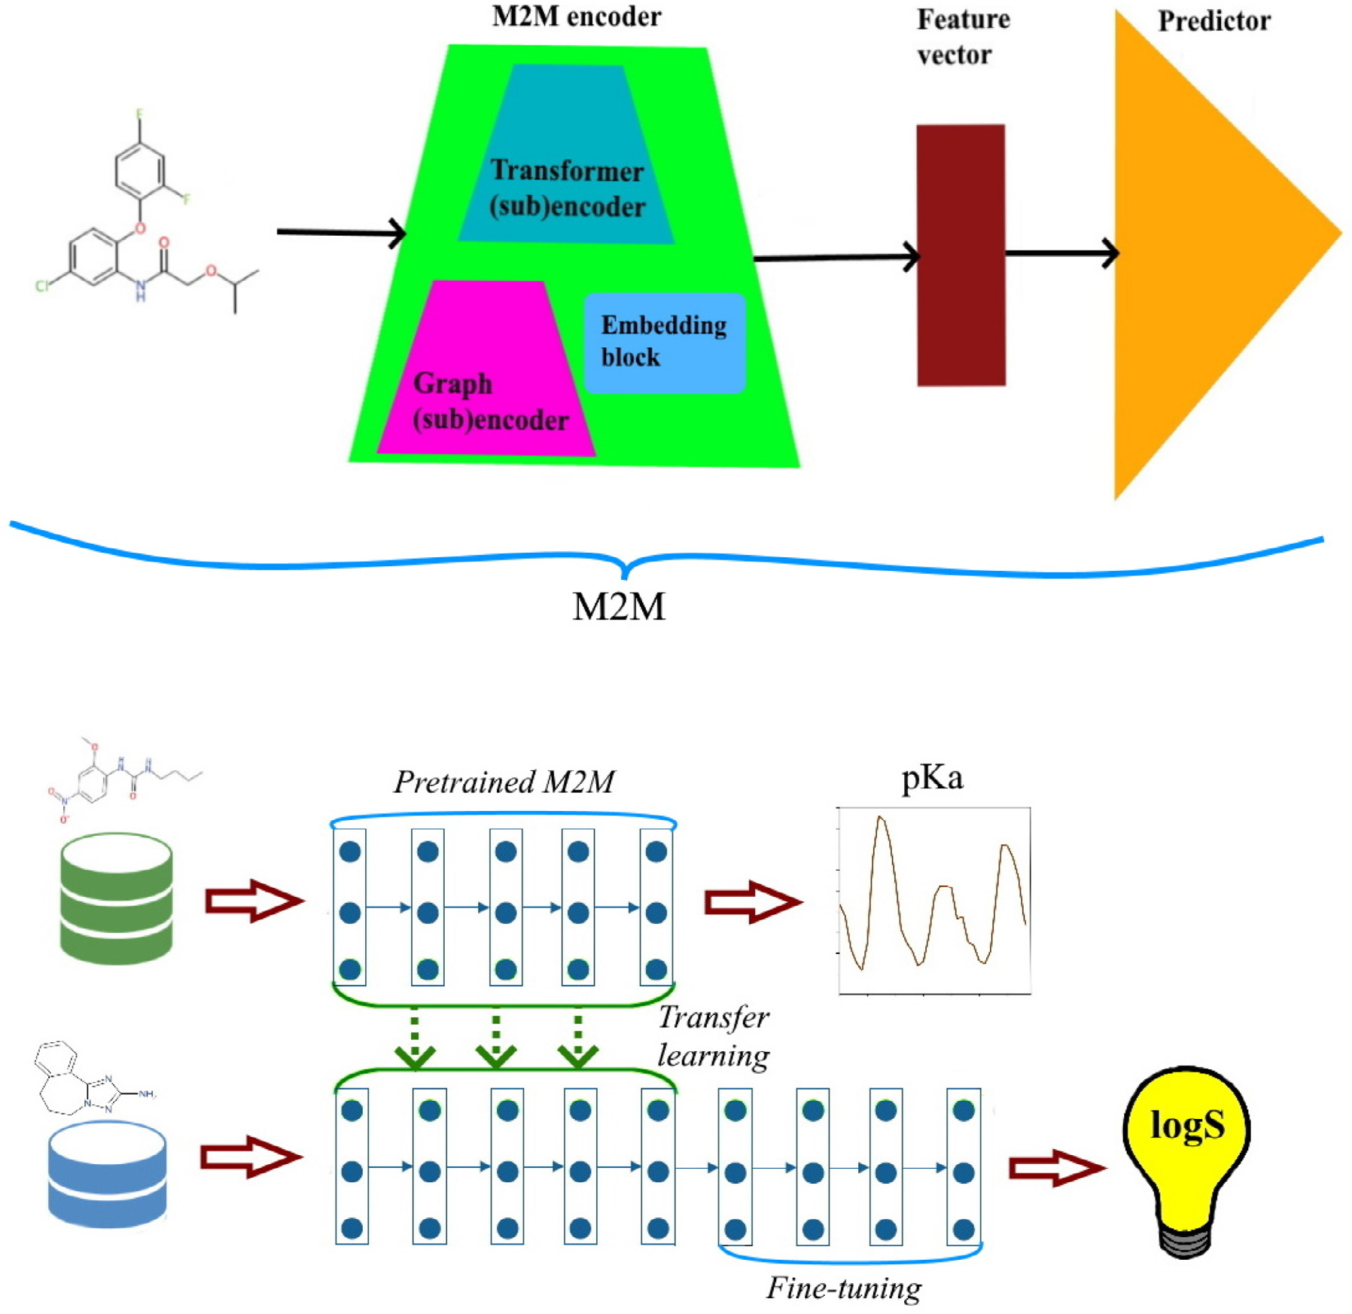

**Fig.1.**ArchitectureofM2MandTunedM2M.

*2.2.Datasetscharacteristics*

Firstly,apKadatasetwasappliedtopretrainourM2Mmodel.Then, log*𝑆* valuesrelatedtoaqueoussolubility[35]wereusedtoM2Mtrans-ferlearningthatwecallTunedM2M.

**DatasetfordevelopingthepretrainedM2M**   
 WeusedatasetthatcontainspKadatafor7911chemicalcompounds, andapplyittopretrainM2M.ThedatacomeasSMILES.Onemayobtain thechemicalsfromtheDataWarrior[36]applicationfolder.According totheanalysisperformedusingToxprintchemotypes[37],thechem-icalstructureshaveahighdiversityoffunctionalgroups.Therefore, theyaresufficienttosupportourresearch,i.e.pretrainM2M.Forthe purposeofthisstudy,preprocessingofthechemicalstructureswasper-formed.Morespecifically,inthefirststep,theminorcomponentsofany multi-componentcompoundswerestripped.Second,duplicatedstruc-tureswereremovedfromtheset.Also,weexcludedinorganicchemicals andmixtures.Thefinal,processedpKadatasetconsistsof6245chemi-calswithmeasuredpKavalues.Fig.3illustratesthesimilaritymapfor pKadataset.Themeasuredvaluesarehighlydiverse(Fig.3).

**DatasetforTunedM2M**   
 ThedatasetweemployinthispaperforM2Mtransferlearningwas obtainedfromOCHEM[35].Itconsistsof1311molecules,whichwere

3

*M.WierciochandJ.Kirchmair*

**Table2**   
Theatom(graphnode)attributesusedformolecularrepresentation.

|  |  |
| --- | --- |
| Attributes | Explanation |
| atomtype  hybridization  chirality  radicalelectrons aromatic  implicitvalence acceptor  donor | C,O,H,N,O,P,… :one-hotencoding  sp,sp2,sp3,sp3d:one-hotencoding  R(Rectus),S(Sinister),N(None):one-hotencoding 0(no),1(yes)  0(no),1(yes)  0(no),1(yes)  0(no),1(yes)  0(no),1(yes) |

**Table3**   
Thebond(graphedge)attributesusedformolecularrepresentation.

|  |  |
| --- | --- |
| Attributes | Explanation |

*ArtificialIntelligenceintheLifeSciences1(2021)100021*

*2.6.Moleculartransformer*

Transformer[41]architecturewasoriginallyproposedforvarious sequence-to-sequencetasks,includingmachinetranslation,andlan-guageunderstanding[42,43].Infact,thehugesuccessoftransformer-basedmodelsisattributedtothemultiheadself-attentioncomponent thatenablesthenetworktocapturecontextualinformationfromthe entiresequence.Amultiheadattentionlayerincludesseveralscaleddot attentionlayersthatruninparallelandareconcatenatedattheend. Incaseofthe*𝑖*thattentionheadandforamatrix*𝐻*∈ ℝ*𝑙*×*𝑑*,theself-attentionmaps*𝐻* intothreematrices:thequerymatrix*𝑄*=*𝐻𝑊𝑄*,the keymatrix*𝐾*=*𝐻𝑊𝐾*andthevaluematrix*𝑉*=*𝐻𝑊𝑉*,where*𝑙* isthe lengthoftheinputsequence,*𝑑* isthedimensionoftheinputsequence, *𝑊𝐾*,*𝑊𝐾*,*𝑊𝑉*arelearnableparameters.Then,theattentionscorescan beexpressedas:

|  |  |  |  |  |
| --- | --- | --- | --- | --- |
| type  partofring  partofconjugation chirality | single,double,triple,aromatic:one-hotencoding 0(no),1(yes)  0(no),1(yes)  E,Z:one-hotencoding | *𝐴𝑡𝑡𝑒𝑛𝑡𝑖𝑜𝑛*(*𝑄,𝐾,𝑉*)=*𝑠𝑜𝑓𝑡𝑚𝑎𝑥*(*𝑄𝐾𝑇 2.7.Molecularembedding* √*𝑑* | )*𝑉.* | (2) |

isnaturallyassociatedwithavectorofattributes*𝑒𝑖,𝑗*.Thereisalsode-finedaneighborhoodfunction*̃𝑁𝑖*={*𝑣𝑗*∶(*𝑣𝑗,𝑣𝑖*)∈ }thatassignsaset ofneighbors*̃𝑁𝑖*toeachvertex*𝑣𝑖*∈ .TheprimarilygoalofGNNsisto learnastatevector*ℎ𝑖*thatisassociatedwitheachvertex*𝑣𝑖*∈ .Inthe beginningthevectorisinitializedas*ℎ*0 *𝑖*=*𝑎𝑖*.Thestateofallthevertices isthenupdateduntilthestoppingcriterionisreached.Theupdatepro-cedureisbasedontheassumptionthateachvertexcommunicateswith itsneighborsbysendingandreceivingmessages.Therefore,thestate*ℎ𝑡 𝑖* ofvertex*𝑣𝑖*atlayer*𝑡*dependsonitsstateatthepreviouslayer,*ℎ𝑡*−1 *𝑖*,and allmessageswhichcamefromneighbors*𝑣𝑗*∈*̃𝑁𝑖*.Ingeneral,itcanbe definedasfollows:

*ℎ𝑡 𝑖*=*𝑈𝑝*(*ℎ𝑡*−1 *𝑖,𝐴𝑔𝑔*({*𝑀*(*𝑣𝑖,𝑣𝑗,𝑡*)∶*𝑣𝑗*∈ *̃𝑁𝑖*}))*,*  (1)

where*𝑈𝑝*isafunctionthatupdatesthestate,*𝐴𝑔𝑔*denotesaneighbor-hoodaggregationfunction,and*𝑀* isamessagefunction.

*2.4.Graphattentionmechanism*

Attentionmechanismindeeplearningwasfirstproposedin2015by Bahdanauetal.[39]toaddressthecommonprobleminnaturallan-guageprocessing,i.e.,translationoflongsequences.Infact,attention allowstoassigningalearnableweighttopairsofelementssuchasnodes inagraphtofocusonthemostrelevantpartsofthegraph.Morefor-mally,attentionisdefinedasafunction

*𝑔*∶*𝑣𝑖*×*̃𝑁𝑖*→ [0*,*1]   
thatforagivenvertex*𝑣𝑖*∈  projectseachvertexin*̃𝑁𝑖*toarelevance scorethatinformshowmuchattentionisgiventoaparticularneigh-borvertex.Ifoneconsidersanattention-basedgraphneuralnetwork, itmeansthatthefunction*𝐴𝑔𝑔*inEq.(1)employsanattentionmecha-nism.Inthiscase,weaddanextraattentioncoefficient*𝛼𝑖,𝑗*tomodify theweightof*ℎ𝑡 𝑗*,where*𝑣𝑗*∈ *̃𝑁𝑖*.

*2.5.Initialfeaturization*

Theinitialatomandbondfeaturesusedinourstudyareshownin Tables2and3,respectively.TheM2M’sinitialattributes*𝑎𝑖*aretheatom featuresforthevertex*𝑣𝑖*∈ ,whiletheM2M’sinitialedgefeatures*𝑒𝑖,𝑗* arethebondfeaturesforanedge(*𝑣𝑖,𝑣𝑗*)∈ .Inordertoextractthese features,RDKit[40]wasused.Finally,theinitialrepresentationofthe atomisa130-dimensionalvector,andtheinputrepresentationofthe edgeisa8-dimensionalvector.

4

*M.WierciochandJ.Kirchmair*  *ArtificialIntelligenceintheLifeSciences1(2021)100021*

**Fig.2.**M2Mnetworkarchitecture.

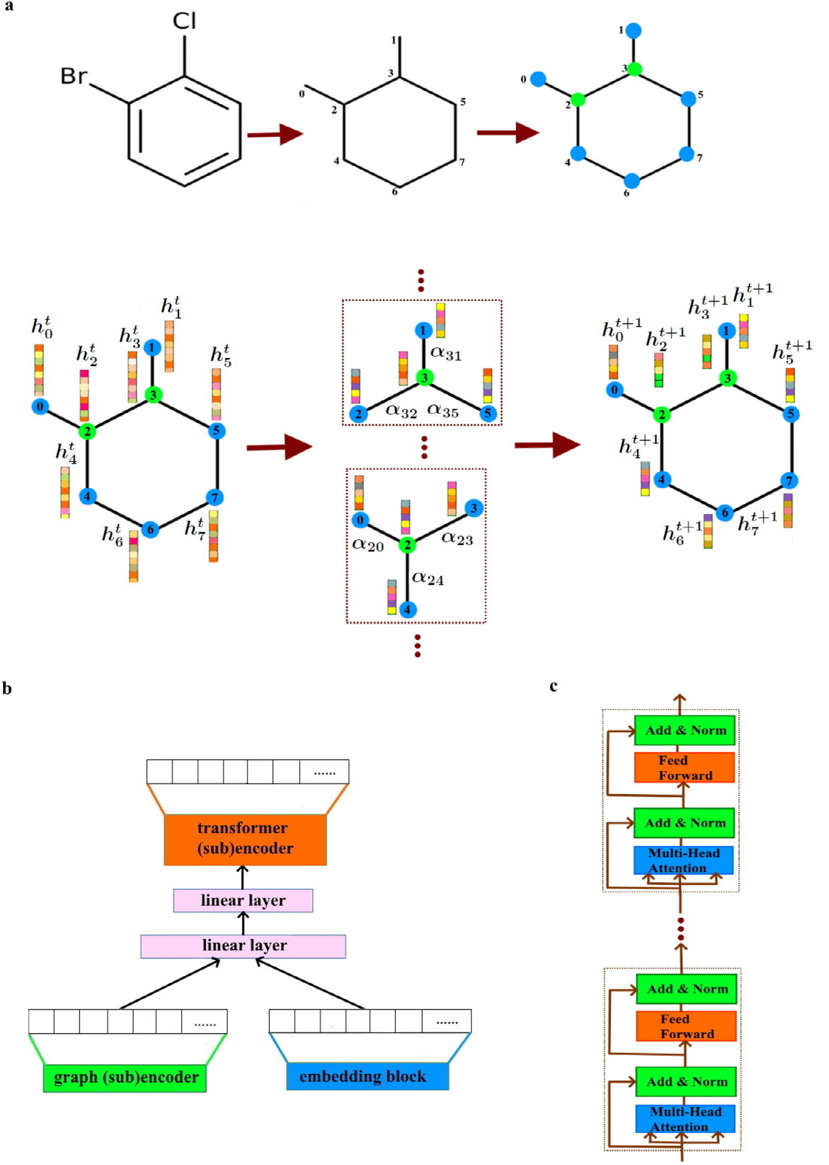

where*𝑊*∈ ℝ*̃𝑑𝑔*×*𝑑𝑔*isaweightmatrix.Furthermore,thevitalcomponent ofeachsinglelayerisanattentioncoefficientthatisassociatedwithan attentionmechanismintroducedinSubsection*Graphattentionmecha-nism*.Morespecifically,duringtheprocess,featuresareconcatenated andparameterizedbyaweightvector*⃖⃗𝑎*∈ ℝ2*̃𝑑𝑔*+*̃𝑒*.Also,nonlinearityis providedby*LeakyReLU*function.Itisinterestingtonotethatweper-formnormalizationusingasoftmaxfunctiondenotedby*𝜎*.Allthese operationscanbeexpressedas:

|  |
| --- |
| exp(*𝜎*(*⃖⃗𝑎𝑇*[*𝑊⃖⃖⃗* *𝛼𝑖𝑗*=  Whatismore,tocapturemultipletypesofrelationshipsbetween∑*𝑘*∈*̃𝑁𝑖*exp(*𝜎*(*⃖⃗𝑎𝑇*[*𝑊⃖⃖⃗ℎ𝑖*||*𝑊⃖⃖⃖⃗ℎ𝑖*||*𝑊⃖⃖⃖⃗ℎ𝑗*||*𝑒𝑖𝑗*])) *ℎ𝑘*||*𝑒𝑖𝑘*])) *.*  (4)  vertices,multiheadattentionisused.Asaresult,weconcatenatethe |

5

*M.WierciochandJ.Kirchmair*  *ArtificialIntelligenceintheLifeSciences1(2021)100021*

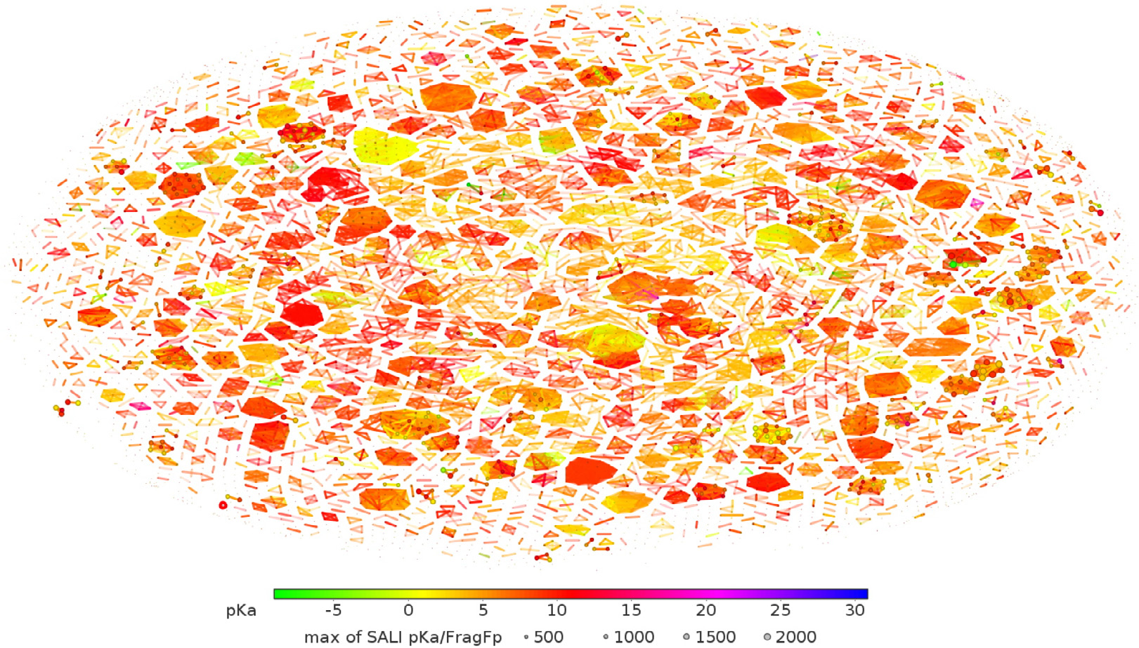

**Fig.3.**SimilaritymapforpKadataset.

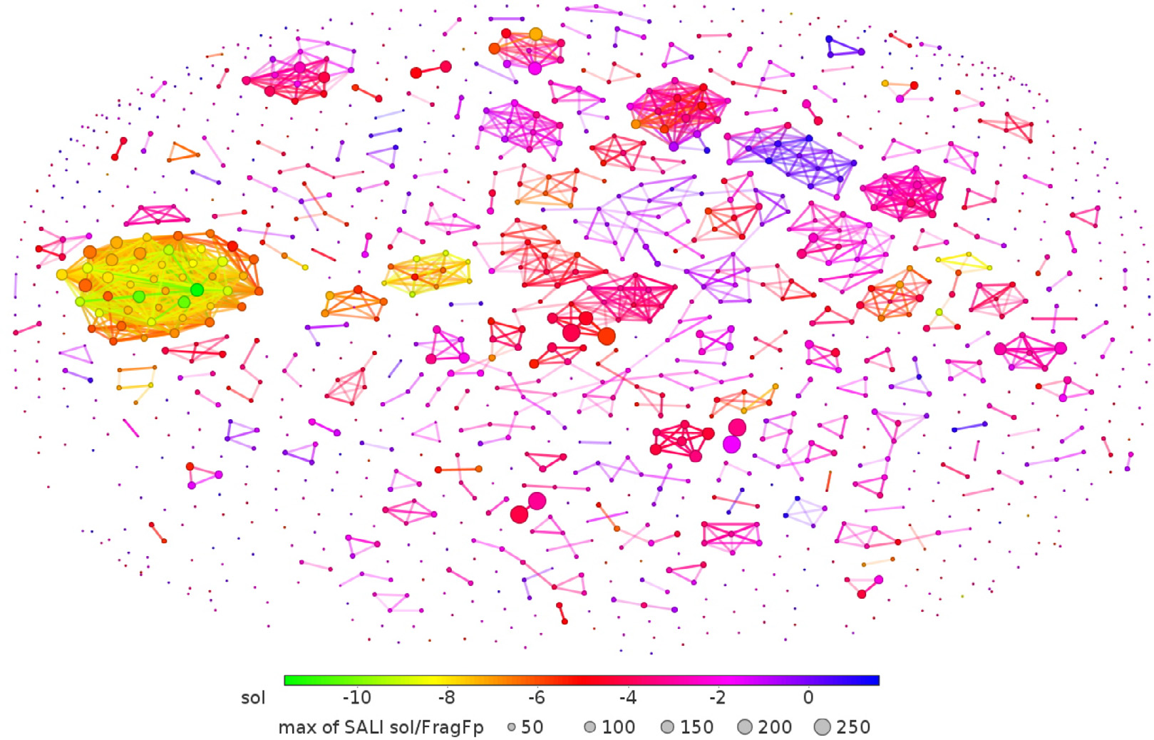

**Fig.4.**Similaritymapforsolubilitydataset.

mizetheaveragelogprobability

|  |
| --- |
| *𝑁* 1 ∑−*𝑐*≤*𝑚*≤*𝑐,𝑚*≠0∑ log*𝑃*(*𝑠𝑖*+*𝑚*|*𝑠𝑖*)*,*  (6)  where*𝑁* isthesizeoftrainingset,*𝑠*1*,𝑠*2*,*… *,𝑠𝑁*arethetrainingSMILES and*𝑐* isthesizeofthetrainingcontext.Moreover,*𝑃*(*𝑠𝑖*+*𝑚*|*𝑠𝑖*)iscalcu-  *𝑃*(*𝑠𝑖*+*𝑚*|*𝑠𝑖*)=exp((*̃𝑢𝑖*+*𝑚*)*𝑇𝑢𝑖*) *𝑘*=1exp((*̃𝑢𝑘*)*𝑇𝑢𝑖*)   *,*  where*𝑆* isthenumberofSMILESinthevocabulary,*𝑈𝑠*,*̃𝑈𝑠*aretheinput andoutputvectorrepresentationsof*𝑠*. |

6

*M.WierciochandJ.Kirchmair*

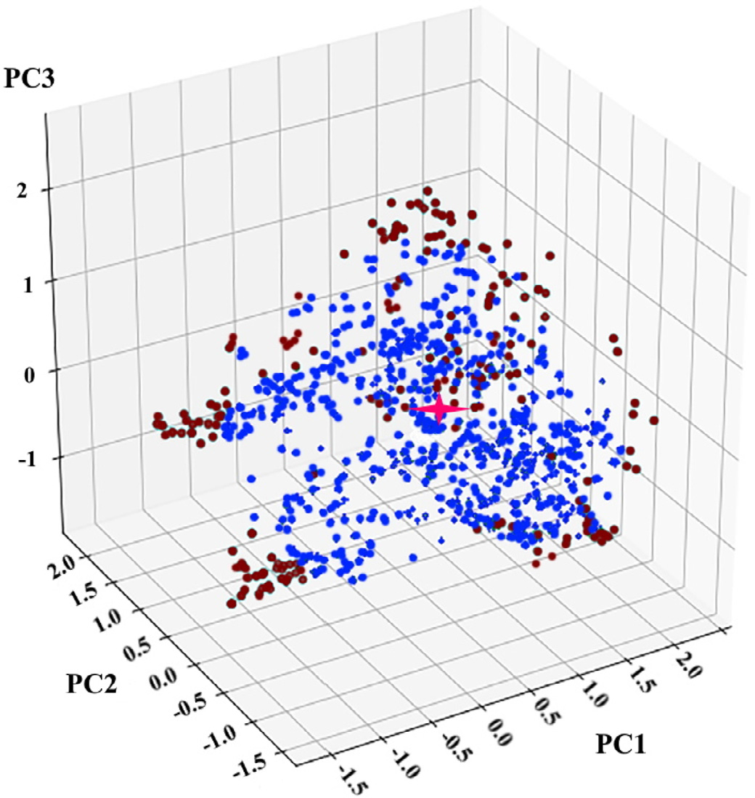

**Fig.5.**PCAscoresplotforthesolubilitydata.Therepresentationreturnedby TunedM2Misprojectedontothreeaxes.

concatenatedrepresentationsasfollows:

*𝑀𝑢𝑙𝑡𝑖ℎ𝑒𝑎𝑑*(*𝑄,𝐾,𝑉*)=*𝐶𝑜𝑛𝑐𝑎𝑡*(*ℎ𝑒𝑎𝑑*1*,*… *,ℎ𝑒𝑎𝑑𝑘*)*𝑊𝑜,*  (7)

where *𝑊𝑜*  is an output projection matrix, and *ℎ𝑒𝑎𝑑𝑖*= *𝐴𝑡𝑡𝑒𝑛𝑡𝑖𝑜𝑛*(*𝑄𝑖,𝐾𝑖,𝑉𝑖*),asEq.(2)indicates(seeFig.2c).Finally,a position-wisefeed-forwardneuralnetworkisappliedtotheoutputof thenetworkthatcanbeexpressedasfollows:

*𝐹𝐹𝑁*(*𝑜𝑢𝑡*)=max(0*,𝑜𝑢𝑡𝑊*1+*𝑏*1)*𝑊*2+*𝑏*2*,*  (8)

where*𝑊*1,*𝑊*2,*𝑏*1,*𝑏*2arekernelandbiasparameters.

*2.8.2.TunedM2M*   
 Intermsofthemaintargettaskofpredictingaqueoussolubilityex-pressedaslog*𝑆*,weoptedtoutilizethelearnedknowledgefromapre-trainednetwork(M2M)andapplythetrainedparameterstoanewre-gressiontaskinaprocesscalledtransferlearning.Therefore,theideais totransfertheweightscalculatedfor*𝑝𝐾𝑎*prediction.Here,wemakeuse oftheencoderandtheembeddinglayerfromM2M.Then,fine-tuning oftheparametersisemployedtoaccommodateaqueoussolubilitypre-diction.TheresultingarchitectureiscalledTunedM2M.

*2.9.Evaluationdetails*

Rootmeansquareerror(RMSE),meanabsoluteerror(MAE),and meansquareerror(MSE)areusedtomeasurethepredictionperfor-mance.Additionally,insomecases,toprovidemorereliableresults, Pearsoncorrelationcoefficient(PCC)andcoefficientofdetermination (*𝑅*2)aregivenaswell.PCCisusedtomeasurethelinearassociation betweentwovariables.Inturn,(*𝑅*2)isseenastheproportionofthe varianceinthedependentvariablethatispredictablefromtheinde-pendentvariables.Moreover,throughoutthispaper,unlessotherwise stated,eachdatasetwasrandomlysplitintoatraining,validation,and testset(80%,10%,and10%,respectively).

7

*M.WierciochandJ.Kirchmair*  *ArtificialIntelligenceintheLifeSciences1(2021)100021*

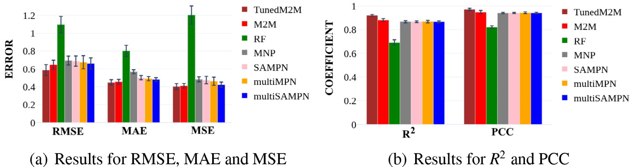

**Fig.6.**Thescoresofvariousmethodsonregressiontaskandtestset.Weachievedthebestresults.

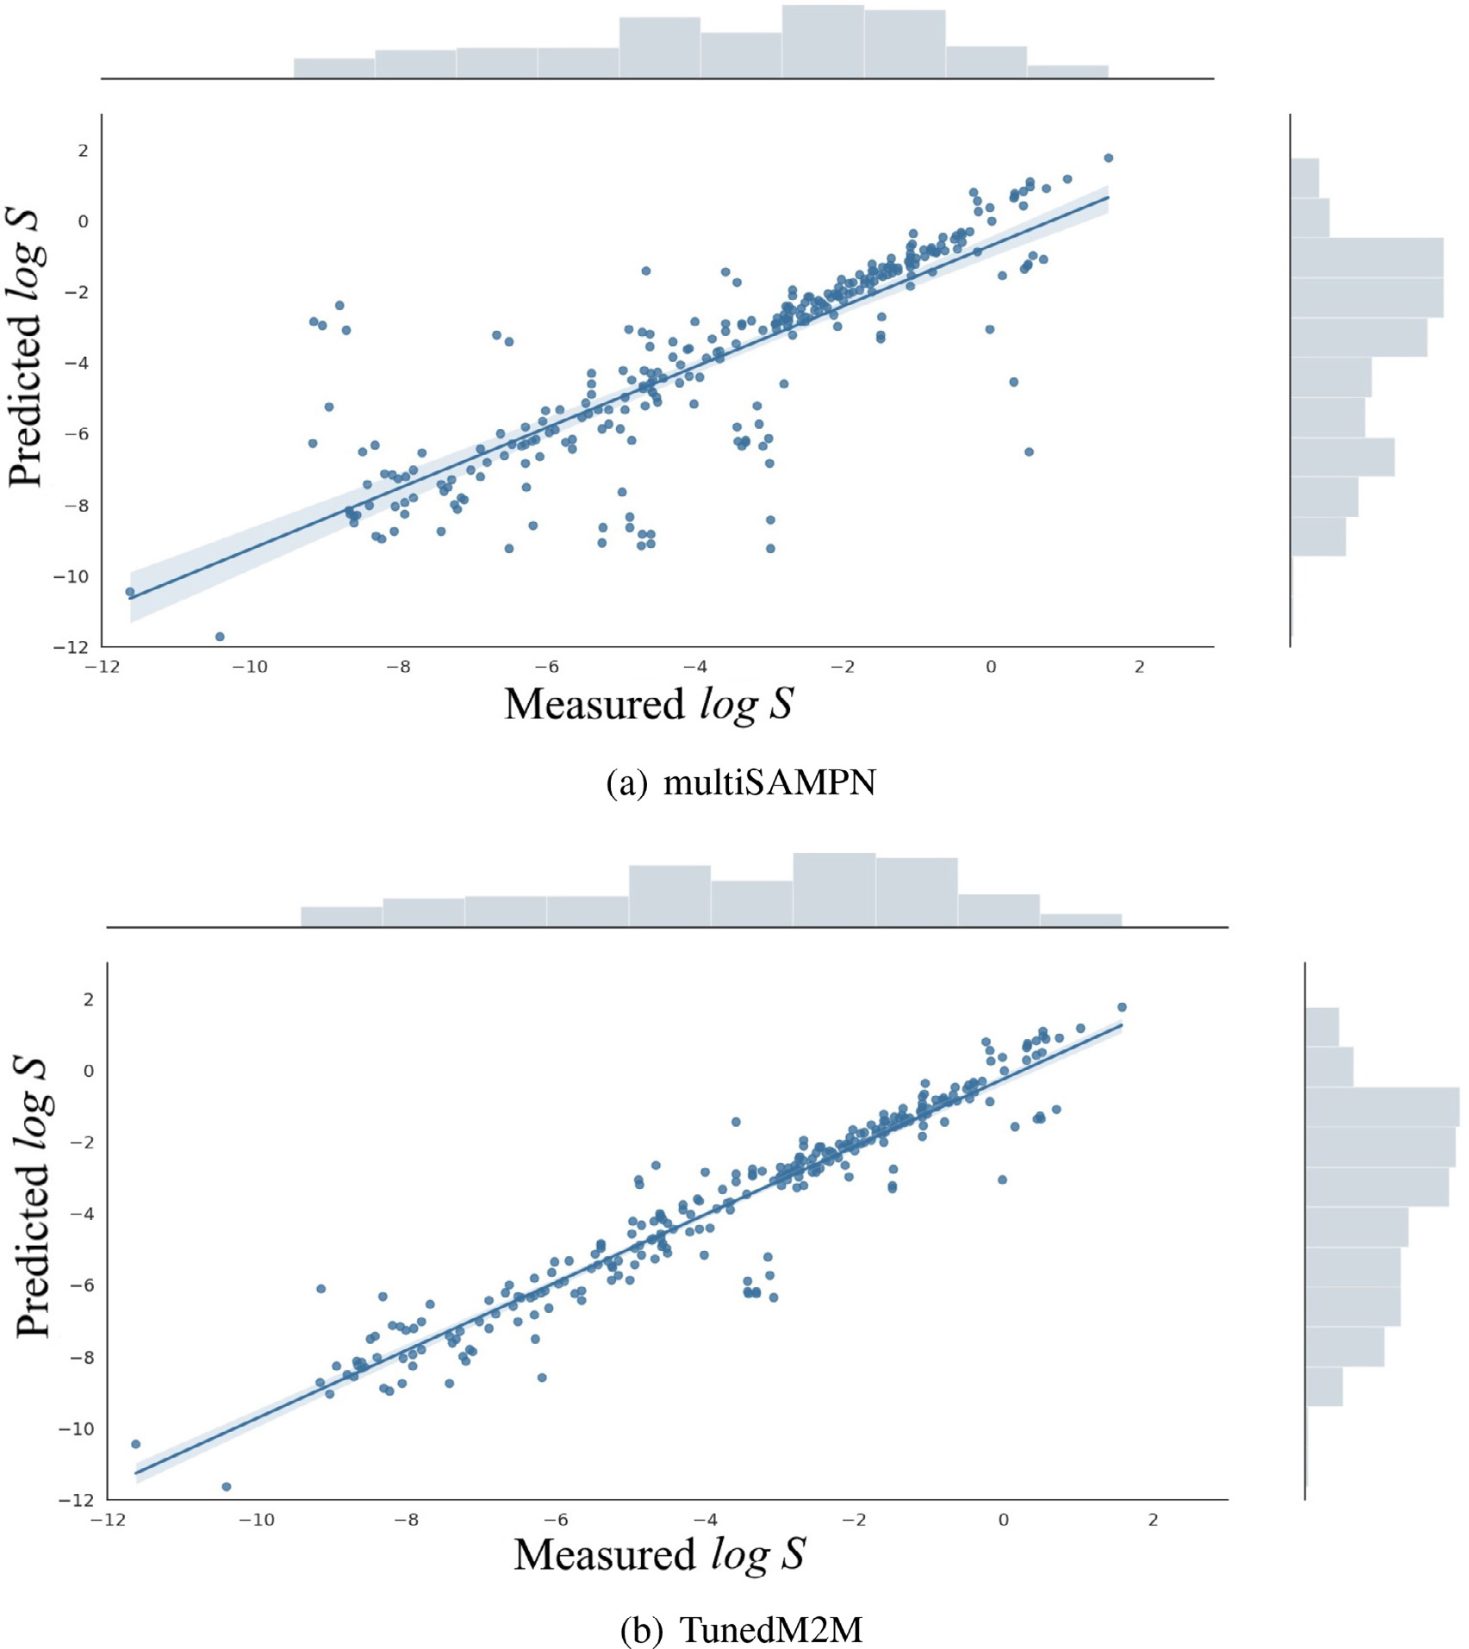

**Fig.7.**Scatterplotformeasuredandcomputationalmodeloutputvaluesofaqueoussolubilityintwodifferentapproaches:(a)multiSAMPN,(b)TunedM2M.

Q2:IsthereanynoticeabledifferencebetweenM2Mwhenlearned onlyontheaqueoussolubilitydataset,andTunedM2M?

ThecomputationaltasksruntoanswerQuestionno.1suggestthat TunedM2MworksbetterthanM2Mtrainedontheaqueoussolubility dataset.Nevertheless,toanswerQ2,weconductedadditionalanalyses:

8

*M.WierciochandJ.Kirchmair*

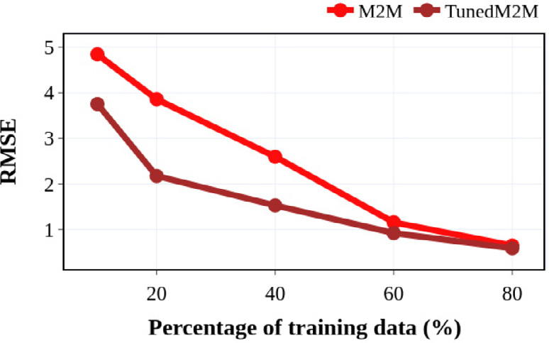

**Fig.8.**PerformanceofM2MandTunedM2Monthedifferentsizeofthetraining set.

ingdata,ourTunedM2MoutperformedinallcasesourM2Mtrained fromscratchonaqueoussolubilitydataset.Thissuggeststhatthetrans-ferlearningstrategythatisappliedintheTunedM2Marchitecturepro-videsarobustimprovementofthemodel.Inotherwords,theoutcomes

*ArtificialIntelligenceintheLifeSciences1(2021)100021*

**Table5**   
Evaluationsofpredictionfor32   
moleculesfromthe2019Solubility   
Challenge[6].

|  |  |
| --- | --- |
| Method | RMSE |
| RF  MPN  SAMPN  multiMPN  multiSAMPN TunedM2M | **1.62**  3.14  3.35  3.24  3.48  3.19 |

meanthatthetrainingofpKadatabenefitsthepredictionofaqueous solubility.

Q3:WhatisthechemicalexplainabilityofTunedM2M?

Weproposeasetoftaskstocheckhoweachatomcontributestothe predictiveperformancegain.Fig.9showstheimpactofatomsatthe exampleofthreeselectedchemicalcompounds.Ingeneral,TunedM2M

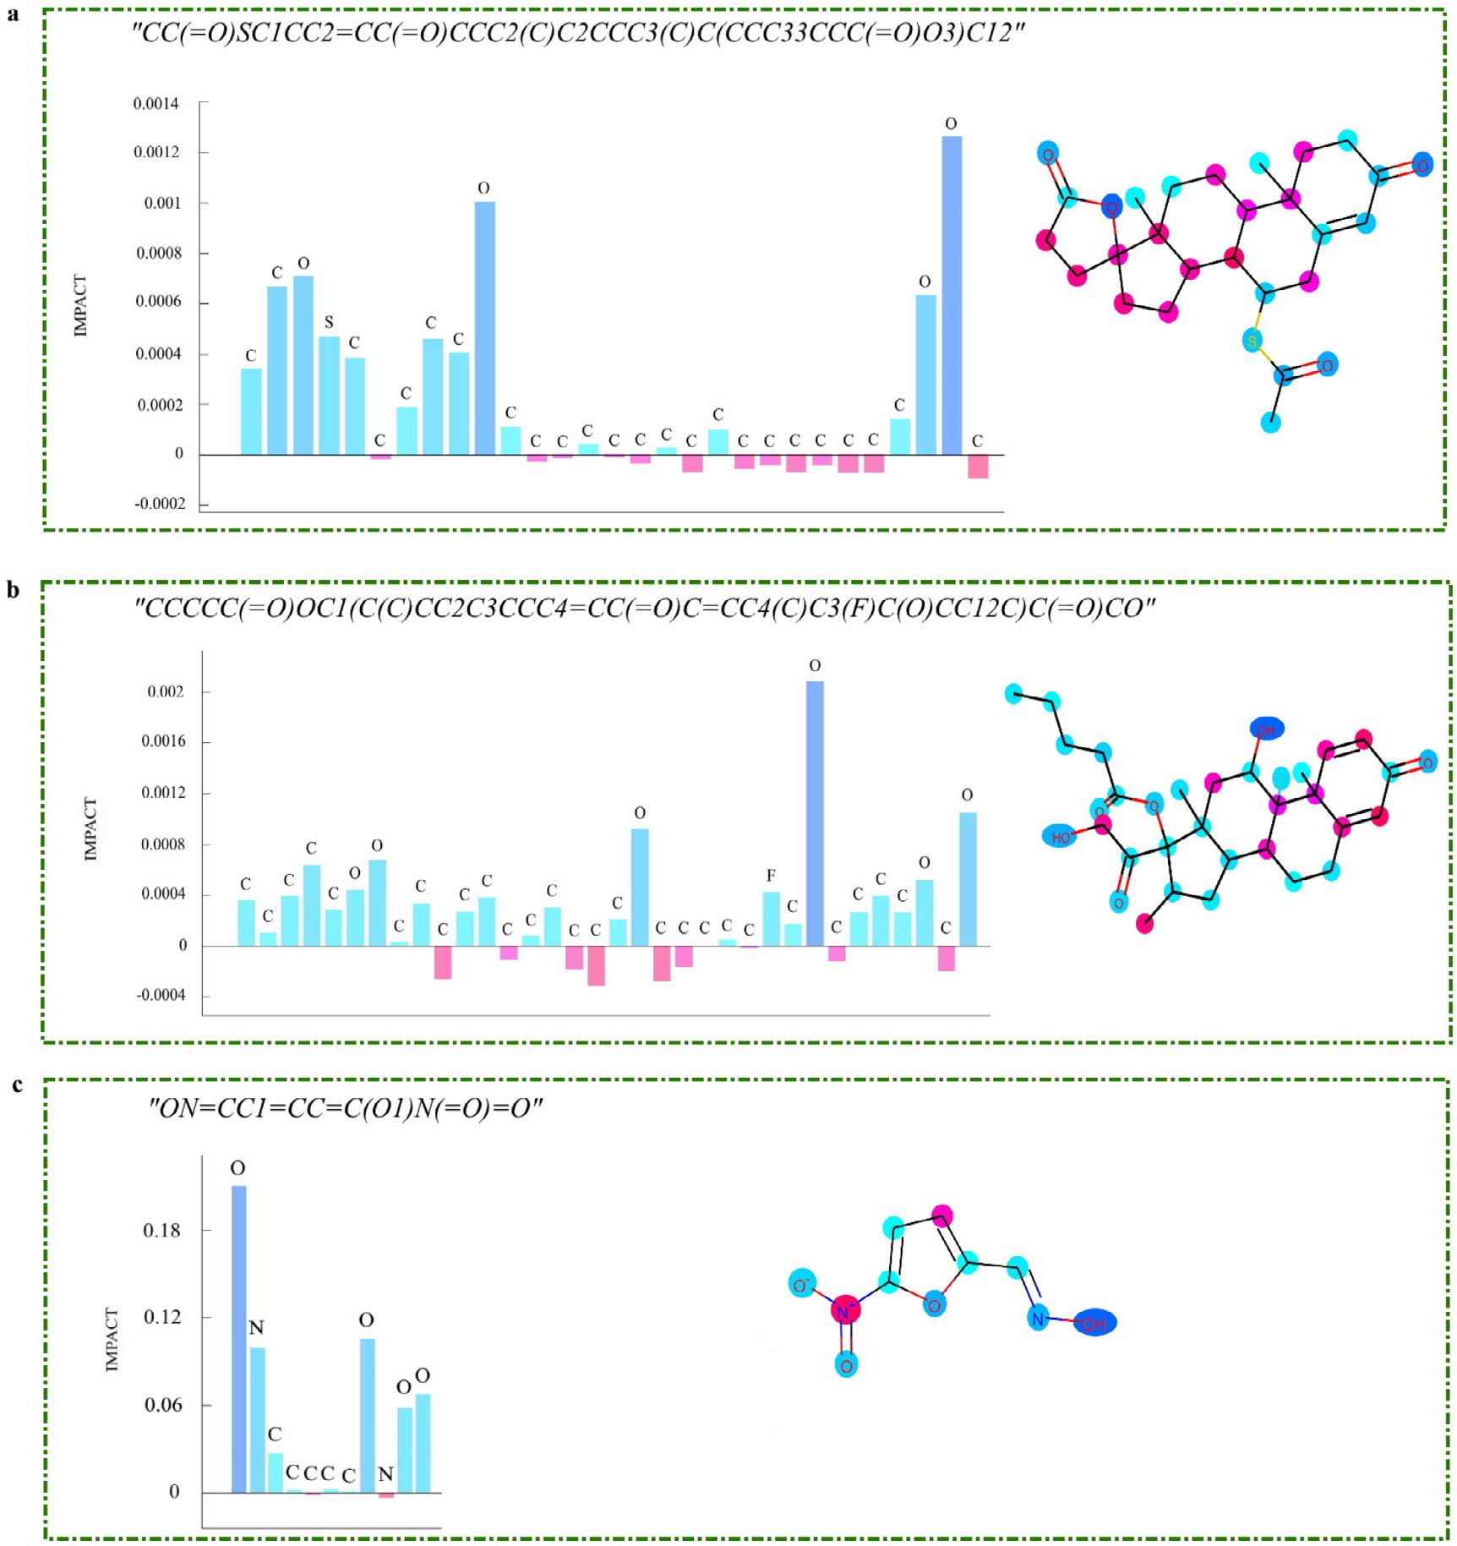

**Fig.9.**Visualizationofatomsandtheircalculatedimpactonaqueoussolubility.PleasenotethatTunedM2Maccuratelyassignsnegativescorestothehydrophobic atomsandpositiveimportancescorestotheatomsthathelpwaterdissolvethesubstance.

9

*M.WierciochandJ.Kirchmair*  *ArtificialIntelligenceintheLifeSciences1(2021)100021*

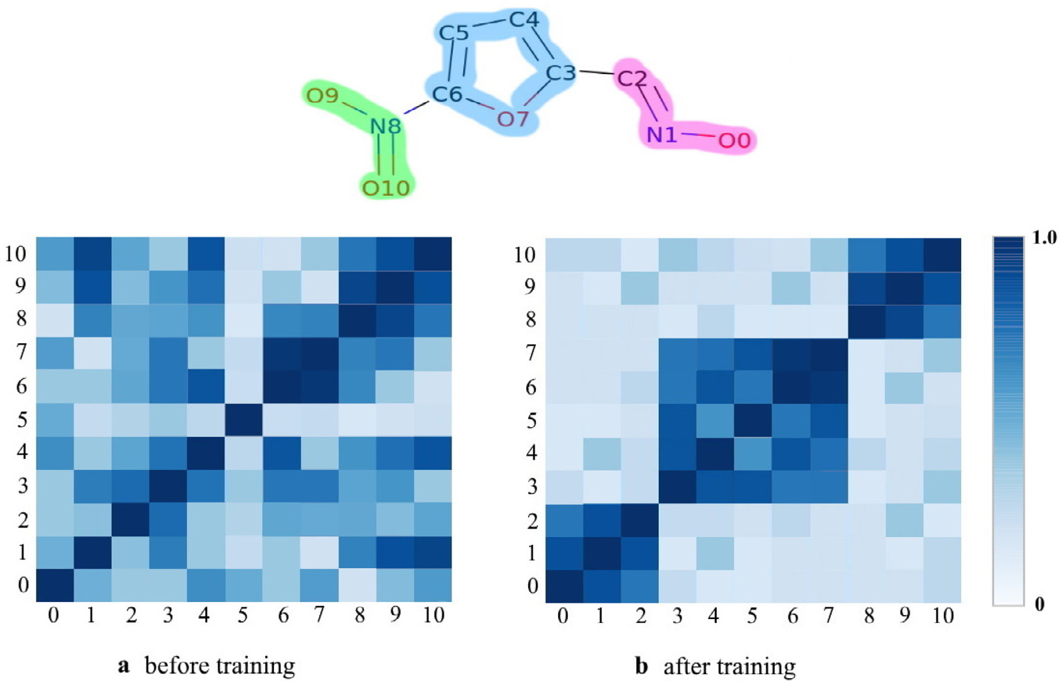

**Fig.10.**Heatmapsoftheatomsimilaritymatrixforthearbitraryselectedmolecule.

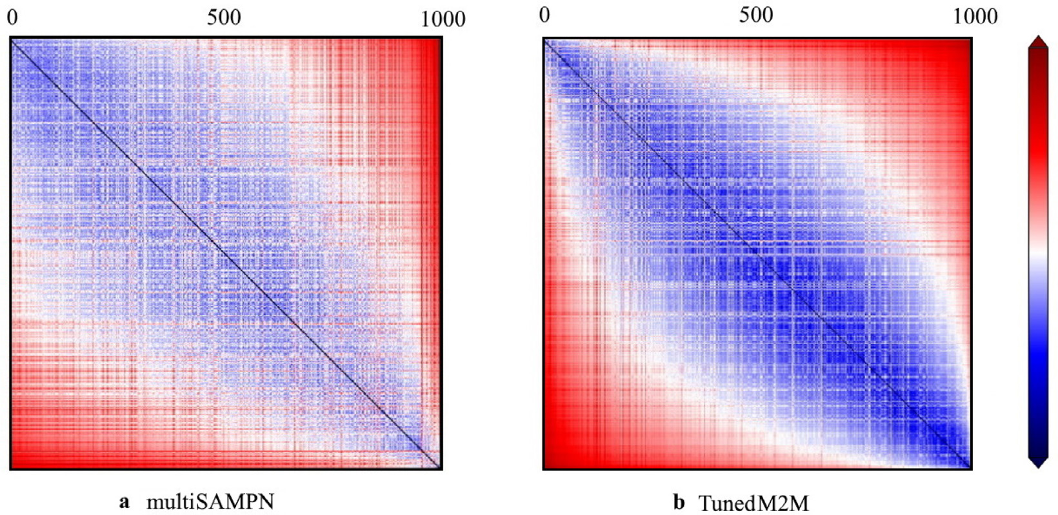

**Fig.11.**2Dplotofthe*𝐿*2-normdistancesbetweenchemicalcompoundsinthelatentspaceassociatedwithlog*𝑆*.Thescalebarontherightsideisassociatedwith thedistancebetweentwomoleculeslabeledbycolumnandrow.

accuratelyassignedpositiveimportancescorestoatomsthatcontribute toaqueoussolubilityandnegativescorestoatomsthatarehydrophobic. Besides,itcanbeobservedthattheatomsthathavepositiveimportance scoresformagroupsthatcanbeassociatedwithsomefunctionalgroups thatarehydrophilic,suchasamines,ketones,aldehydesorethers. Q4:WhatistheinterpretabilityofTunedM2M?

InordertogetmoreinsightintoTunedM2Mandtogainabetterun-derstandingofitsperformance,weselectedanexemplarymoleculepre-sentedinFig.9candanalyzedhowtheatomstatevectorschangeduring thelearningprocess.Fig.10showsheatmapsoftheatomsimilarityma-trixfortheselectedchemicalcompound.Indeed,onemaynoticethat thepatternaftertrainingisdifferentfromthepatternobservedbefore training.Fig.10ademonstratesthattheheatmapofthesimilaritymatrix revealssimilarlevelsofrandomnessacrossdifferentlayers.Incontrast, aftertraining,weobtainthreeclustersofatomsthatareassociatedwith functionalgroups:anoximegroup(atomsno.0,1,2),anarenegroup

10

*M.WierciochandJ.Kirchmair*  *ArtificialIntelligenceintheLifeSciences1(2021)100021*

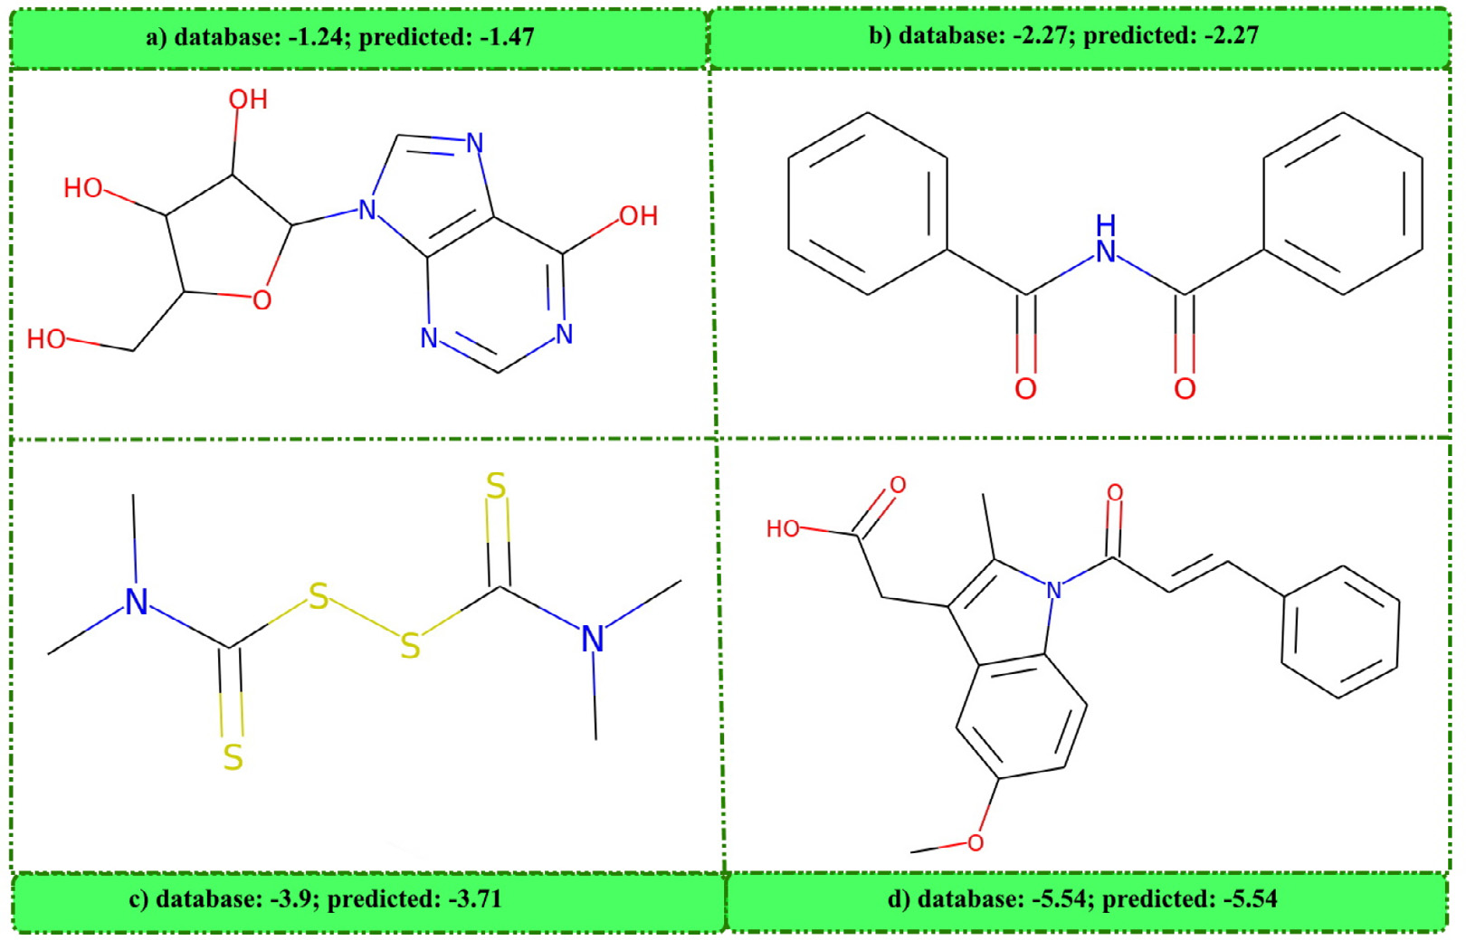

**Fig.12.**Selectionofchemicalcompoundsandpredictedvalues.

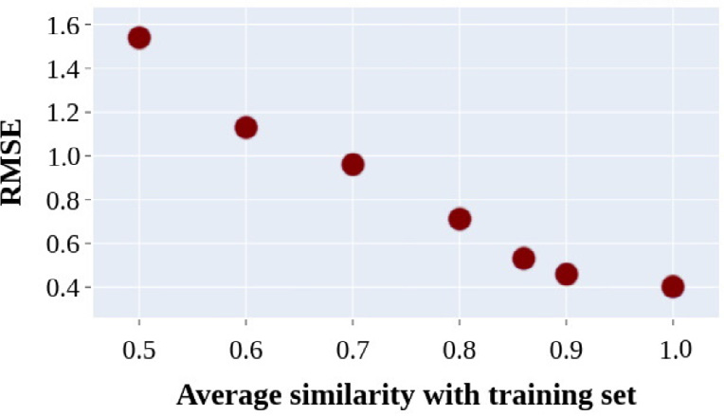

**Fig.13.**Predictionerror(measuredasRMSE)versustheaveragesimilarityof themoleculetotherestofthetrainingset.

less,TunedM2Mputschemicalcompoundsthathavesimilarproper-tiesclosertoeachotherinspace,andthatexplainstheperformanceof TunedM2M(Figs.12and13).

Q6:Doestheusageof(sub)encodersaffectthefinalperformanceof M2M?

Toinvestigatethecontributionofdifferentfactorsthatinfluence theperformanceofM2M,weconductedablationstudies.Asshown

inFig.14,decouplingknowledge-awarecomponentssuchasagraph (sub)encoderandanembeddingblockinM2Mencoderfromourlearn-ingframeworkyieldsasignificantdropofperformance.Moreover,it seemsthatagraph(sub)encoderiscrucialandeffectiveforbetterre-sults.Inaddition,thelackoftransformercausestheworstperformance. Q7:Doesscaffold-basedsplittingofthedataaffecttheperformance ofM2MandTunedM2M?

Wealsoevaluatethemodelsonscaffold-basedsplit.Scaffoldsplit-tingisperformedusingBemis-Murcko[50]methodologythatdivides thedatasetintoatrainingset,avalidationset,andatestsetaccordingto theirtwo-dimensionalmolecularstructures.AstheFig.15shows,both M2MandTunedM2Mbeatallthecompetitiveapproaches.Tobemore precise,TunedM2MreachesanRMSEof0.672,MAEof0.501,andMSE of0.438.Thesecond-bestapproachisM2Mtrainedonlyonaqueoussol-ubilitydataset(RMSE=0.721,MAEof0.564MSEof0.471),whilethe third-bestismultiSAMPNthatobtainsanRMSEof0.735,MAEof0.571, andMSEof0.48.Infact,theresultsindicatethatscaffoldsplittingisa morechallengingsettingsinceityieldslessimpressivescoresthanthe randomsplitapproach.Nevertheless,theoutcomesindicatethateven whenthetrainingandthetestsethavedifferentcharacteristicsrelated tothemolecularstructures,theTunedM2Misabletolearnthegeneral representationofthemoleculesandreturnsacompetitiveprediction.

|  |  |
| --- | --- |
|  | **Fig.14.**Ablationstudies.Afterremovingagraph (sub)encoder,anembeddingblockandatransformerin M2Mencoderfromourlearningframework,asignificantdrop ofperformanceisobserved. |

11

*M.WierciochandJ.Kirchmair*

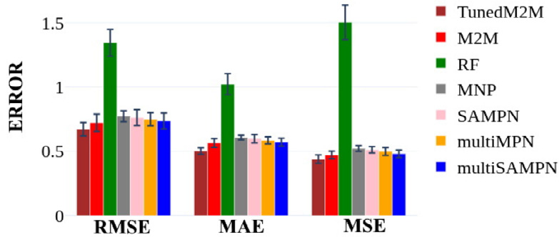

**Fig.15.**Scaffoldsplit.Thescoresofvariousmethodsonregressiontaskand testset.Weachievedthebestresults.

Q8:Howdoesthemodelworkforadatasetofintrinsicwatersolu-bility?

Aspartofanadditionaltask,weapplytheproposedmodeltothe moleculesprovidedbytheorganisersofthe2019SolubilityChallenge [6].ItissomewhatnotsurprisingthatRFobtainsthebestresults,i.e., RMSEof1.62(seeTable5).Itshowsthatforanextremelysmalldataset, including100moleculesinthetrainingset,deeplearning-basedap-proachesrevealveryhigherroronatestset(32molecules).Although TunedM2M’sperformanceisnotsatisfactory,itachievesthethirdbest result(RMSEof3.19).Wehopethisobservationwillhelptoexplorefur-therthechallengesconnectedwithpredictionoftheintrinsicsolubilities ofmoleculesforsmalldatasets.

**4.Conclusions**

Toincreasetheaccuracyofaqueoussolubilitypredictionandover-comethedifficultiesoftrainingdeepneuralnetworkscausedbylimited reliableaqueoussolubility-relateddatasets,inthiswork,weintroduced atransformer-basedarchitecture.Moreover,weemployedatransfer learningstrategyandcalledthefinalarchitectureasTunedM2M.This paperpresentstheworkflowandperformanceofourmethod.Infact, thankstothewell-designedencoder,TunedM2Mprovidesinsightson whichfragmentsofthechemicalstructurehavethegreatestinfluence onthepropertyofinterest.Furthermore,severalproposedtaskshave shownourapproachiscompetitivewiththestate-of-the-artmodels.The resultsalsodemonstratedthattheaccuracyoftheaqueoussolubility predictionwassignificantlyimproved.Therefore,theoutcomesreveals thattransferlearningisaneffectivewaytosolvethedata-hungryprob-lemandmaybebeneficialforimprovingtheregressionperformanceof othermodels.

*4.1.Dataandsoftwareavailability*

[OurmodelwasimplementedusingPython3.7andPytorch1.2.0. Thefile](https://github.com/magdalenawi/TunedM2M)s[usedinthisstudyareavailableonGithub(https://github.com/ magdalenawi/TunedM2M).](https://github.com/magdalenawi/TunedM2M)

*4.1.1.Authorcontributions*   
 M.W.contributedtheconcept,implementationandwrotethe manuscript.M.WandJ.K.contributedtotheinterpretationofresults. Allauthorsreviewedandapprovedthefinalmanuscript.

**Funding**

ThisworkisapartofbroaderresearchfundedundertheIwanowska ProgramofthePolishNationalAgencyforAcademicExchange(NAWA)-adecisionno.PPN/IWA/2018/1/00094/DEC/1.Thisresearchwas alsosupportedbytheNationalScienceCentre(Poland)GrantsNo. 2016/21/N/ST6/01019.Thispublicationhasbeenpartiallyfunded fromtheSciMatPriorityResearchAreabudgetundertheprogram“Ex-cellenceInitative-ResearchUniversity” attheJagiellonianUniversity.

*ArtificialIntelligenceintheLifeSciences1(2021)100021*

**DeclarationofCompetingInterest**

Theauthorsdeclarethattheyhavenoknowncompetingfinancial interestsorpersonalrelationshipsthatcouldhaveappearedtoinfluence theworkreportedinthispaper.

**Supplementarymaterial**

Supplementarymateri[alassociatedwiththisarticlec](https://doi.org/10.1016/j.ailsci.2021.100021)anbefound,in theonlineversion,atdoi:[10.1016/j.ailsci.2021.100021](https://doi.org/10.1016/j.ailsci.2021.100021).

**References**

[1][ZhangL,TanJ,HanD,ZhuH.Frommachinelearningtodeeplearning: progress](http://refhub.elsevier.com/S2667-3185(21)00021-0/sbref0001)in[machineintelligenceforrationaldrugdiscovery.DrugDiscovToday 2017;22(11):1680–5.](http://refhub.elsevier.com/S2667-3185(21)00021-0/sbref0001)

[2][HannMM.Molecularobesity,potencyandotheraddictionsindrugdiscovery.Med-](http://refhub.elsevier.com/S2667-3185(21)00021-0/sbref0001) [chemcom](http://refhub.elsevier.com/S2667-3185(21)00021-0/sbref0003)[m2011;2(5):349–55.](http://refhub.elsevier.com/S2667-3185(21)00021-0/sbref0002)

[3][BoobierS,](http://refhub.elsevier.com/S2667-3185(21)00021-0/sbref0003)[OsbournA,MitchellJB.Canhumanexpertspredictsolubilitybetterthan](http://refhub.elsevier.com/S2667-3185(21)00021-0/sbref0002)  [computers?JCheminform2017;9(1):1–14.](http://refhub.elsevier.com/S2667-3185(21)00021-0/sbref0003)

[4][WangJ,HouT.Recentadvancesonaqueoussolubilityprediction.CombChemHigh](http://refhub.elsevier.com/S2667-3185(21)00021-0/sbref0003)  [ThroughputScreening2011;14(5):328–38.](http://refhub.elsevier.com/S2667-3185(21)00021-0/sbref0004)

[5][PalmerDS,MitchellJB.Isexperimentaldataqualitythelimitingfactorinpredicting](http://refhub.elsevier.com/S2667-3185(21)00021-0/sbref0004) [theaqueoussolubilityofdruglikemolecules?MolPharm2014;11(8):2962–72.](http://refhub.elsevier.com/S2667-3185(21)00021-0/sbref0005)

[6][LlinasA,AvdeefA.Solubilitychallengerevisitedaftertenyears,withmultilab](http://refhub.elsevier.com/S2667-3185(21)00021-0/sbref0005) [shake-flaskdata,usingtight(SD0.17log)andloose(SD0.62log)testsets.J ChemInfModel2019;59(6):3036–40.](http://refhub.elsevier.com/S2667-3185(21)00021-0/sbref0006)

[7][DeardenJC.Insilicopredictionofaqueoussolubility.ExpertOpinDrugDiscov](http://refhub.elsevier.com/S2667-3185(21)00021-0/sbref0006)  [2006;1(1):31–52.](http://refhub.elsevier.com/S2667-3185(21)00021-0/sbref0007)

[8][Jiménez-LunaJ,GrisoniF,SchneiderG.Drugdiscoverywithexplainableartificia](http://refhub.elsevier.com/S2667-3185(21)00021-0/sbref0007)l [intelligence.NatMachIntell2020;2(10):573–84.](http://refhub.elsevier.com/S2667-3185(21)00021-0/sbref0008)

[9][FühnerH.Diewasserloslichkeitinhomologenreihen.Berichtederdeutschen](http://refhub.elsevier.com/S2667-3185(21)00021-0/sbref0008)  [chemischenGesellschaft(AandBSeries)1924;57(3):510–15.](http://refhub.elsevier.com/S2667-3185(21)00021-0/sbref0010)

[10][HanschC,QuinlanJ,LawrenceG.TheLinearFree-EnergyRelationshipbetween PartitionCoefficien](http://refhub.elsevier.com/S2667-3185(21)00021-0/sbref0010)ts[andtheAqueousSolubilityofOrganicLiquids.JOrgChem 1924.](http://refhub.elsevier.com/S2667-3185(21)00021-0/sbref0010)

[11][KamletMJ,DohertyRM,AbboudJ-LM,AbrahamMH,TaftRW.Linearsolvation](http://refhub.elsevier.com/S2667-3185(21)00021-0/sbref0010) [energyrelationships:36.Molecularpropertiesgoverningsolubilitiesoforganicnon-electrolytesinwater.JPharmSci1986;75(4):338–49.](http://refhub.elsevier.com/S2667-3185(21)00021-0/sbref0011)

[12][YalkowskySH,ValvaniSC.Solubilityandpartitioningi:solubilityofnonelectrolytes](http://refhub.elsevier.com/S2667-3185(21)00021-0/sbref0011)  [inwater.JPharmSci1980;69(8):912–22.](http://refhub.elsevier.com/S2667-3185(21)00021-0/sbref0012)

[13][EricksonL..Thesolubilityofhomologousseriesoforganiccompounds.1952.](http://refhub.elsevier.com/S2667-3185(21)00021-0/sbref0012) [14][HewittM,CroninMT,EnochSJ,MaddenJC,RobertsDW,DeardenJC.Insil-](http://refhub.elsevier.com/S2667-3185(21)00021-0/sbref0014) [icopredictionofaqueoussolubility:thesolubilitychallenge](http://refhub.elsevier.com/S2667-3185(21)00021-0/sbref0014).[JChemInfModel](http://refhub.elsevier.com/S2667-3185(21)00021-0/sbref0014)  [2009;49(11):2572–87.](http://refhub.elsevier.com/S2667-3185(21)00021-0/sbref0014)

[15][PalmerDS,O’BoyleNM,GlenRC,MitchellJB.Randomforestmodelstopredict](http://refhub.elsevier.com/S2667-3185(21)00021-0/sbref0014)  [aqueoussolubility.JChemInfModel2007;47(1):150–8.](http://refhub.elsevier.com/S2667-3185(21)00021-0/sbref0015)

[16][LindP,MaltsevaT.Supportvectormachinesfortheestimationofaqueoussolubility.](http://refhub.elsevier.com/S2667-3185(21)00021-0/sbref0015)  [JChemInfComputSci2003;43(6):1855–9.](http://refhub.elsevier.com/S2667-3185(21)00021-0/sbref0016)

[17][KönczölÁ,Dargó G.Briefoverviewofsolubilitymethods:recenttrendsin](http://refhub.elsevier.com/S2667-3185(21)00021-0/sbref0016) [equilibriumsolubilitymeasurementandpredictivemodels.DrugDiscovToday 2018;27:3–10.](http://refhub.elsevier.com/S2667-3185(21)00021-0/sbref0017)

[18][Erić S,Kalinić M,Popović A,ZlohM,KuzmanovskiI.Predictionofaqueoussolubility](http://refhub.elsevier.com/S2667-3185(21)00021-0/sbref0017) [ofdrug-likemoleculesusin](http://refhub.elsevier.com/S2667-3185(21)00021-0/sbref0018)g[anovelalgorithmforautomaticadjustmentofrelative importanceofdescriptorsimplementedincounter-propagationartificialneuralnet-works.IntJPharm2012;437(1–2):232–41.](http://refhub.elsevier.com/S2667-3185(21)00021-0/sbref0018)

[19][KrizhevskyA,SutskeverI,HintonGE.ImageNetclassificatio](http://refhub.elsevier.com/S2667-3185(21)00021-0/sbref0018)n[withdeepconvolu-](http://refhub.elsevier.com/S2667-3185(21)00021-0/sbref0018) [tionalneuralnetworks.CommunACM2017;60(6):84–90.](http://refhub.elsevier.com/S2667-3185(21)00021-0/sbref0019)

[20][ChenL-C,ZhuY,PapandreouG,Schroff](http://refhub.elsevier.com/S2667-3185(21)00021-0/sbref0019) F[,AdamH.Encoder-decoderwithatrous](http://refhub.elsevier.com/S2667-3185(21)00021-0/sbref0019) [separableconvolutionforsemanticimagesegmentation.In:ProceedingsoftheEu-ropeanconferenceoncomputervision(ECCV);2018.p.801–18.](http://refhub.elsevier.com/S2667-3185(21)00021-0/sbref0020)

[21][YangW,ZhangX,TianY,WangW,XueJ-H,LiaoQ.Deeplearningforsingleimage](http://refhub.elsevier.com/S2667-3185(21)00021-0/sbref0020) [super-resolution:abriefreview.IEEETransMultimedia2019;21(12):3106–21.](http://refhub.elsevier.com/S2667-3185(21)00021-0/sbref0021)

[22][DuvenaudDK,MaclaurinD,IparraguirreJ,BombarellR,HirzelT,Aspuru-GuzikA,](http://refhub.elsevier.com/S2667-3185(21)00021-0/sbref0021) [etal.Convolutionalnetworksongraphsforlearningmolecularfingerprints](http://refhub.elsevier.com/S2667-3185(21)00021-0/sbref0022).[Adv](http://refhub.elsevier.com/S2667-3185(21)00021-0/sbref0022) [NeuralInfProcessSyst2015;28:2224–32.](http://refhub.elsevier.com/S2667-3185(21)00021-0/sbref0023)

[23][KearnesS,McCloskeyK,BerndlM,PandeV,RileyP.Moleculargraphconvolutions:](http://refhub.elsevier.com/S2667-3185(21)00021-0/sbref0023)  [movingbe](http://refhub.elsevier.com/S2667-3185(21)00021-0/sbref0024)[yondfingerp](http://refhub.elsevier.com/S2667-3185(21)00021-0/sbref0023)rints.[JCom](http://refhub.elsevier.com/S2667-3185(21)00021-0/sbref0024)[putAide](http://refhub.elsevier.com/S2667-3185(21)00021-0/sbref0023)[dMolDes2016;30(8):595–608.](http://refhub.elsevier.com/S2667-3185(21)00021-0/sbref0024)

[24][WójcikowskiM,KukiełkaM,Stepniewska-DziubinskaMM,SiedleckiP.Development ofaprotein–ligand](http://refhub.elsevier.com/S2667-3185(21)00021-0/sbref0024)extended[connectivity(PLEC)fingerprintanditsapplicationfor](http://refhub.elsevier.com/S2667-3185(21)00021-0/sbref0024) [bindingaffini](http://refhub.elsevier.com/S2667-3185(21)00021-0/sbref0025)ty[predictions.Bioinformatics2019;35(8):1334–41.](http://refhub.elsevier.com/S2667-3185(21)00021-0/sbref0025)

[25][LouisS-Y,ZhaoY,NasiriA,WangX,SongY,LiuF,etal.Graphconvolutionalneural networkswithglobalattentionforimprovedmaterialspropertyprediction.PCCP 2020;22(32):18141–8.](http://refhub.elsevier.com/S2667-3185(21)00021-0/sbref0025)

[26][LeCunY,BengioY,Hinton](http://refhub.elsevier.com/S2667-3185(21)00021-0/sbref0025)G[.Deeplearning.Nature2015;521(7553):436–44.](http://refhub.elsevier.com/S2667-3185(21)00021-0/sbref0026) [27][WeiningerD.Smiles,achem](http://refhub.elsevier.com/S2667-3185(21)00021-0/sbref0027)[icallanguageandinformationsystem.1.Introdu](http://refhub.elsevier.com/S2667-3185(21)00021-0/sbref0026)[ction](http://refhub.elsevier.com/S2667-3185(21)00021-0/sbref0027)  [tomethodologyandencodingrules.JChemInfComputSci1988;28(1):31–6.](http://refhub.elsevier.com/S2667-3185(21)00021-0/sbref0027)

[28][LusciA,PollastriG,BaldiP.Deeparchitecturesanddeeplearninginchemoinformat-](http://refhub.elsevier.com/S2667-3185(21)00021-0/sbref0027)[ics:thepredictionofaqueoussolubilityfordrug-likemolecules.JChemInfModel](http://refhub.elsevier.com/S2667-3185(21)00021-0/sbref0028) [2013;53(7):1563–75.](http://refhub.elsevier.com/S2667-3185(21)00021-0/sbref0029)

[29][WuK,ZhaoZ,WangR,WeiG-W.TopP–S:persistenthomology-basedmulti-task deepneuralnetworksforsimultaneouspredictionsofpartitioncoefficientandaque-oussolubility.JComputChem2018;39(20):1444–54.](http://refhub.elsevier.com/S2667-3185(21)00021-0/sbref0029)

12

*M.WierciochandJ.Kirchmair*

[[30]LiuK,SunX,JiaL,MaJ,XingH,WuJ,etal.Chemi-Net:amolecular graphconvolutionalnetworkforaccura](http://refhub.elsevier.com/S2667-3185(21)00021-0/sbref0030)te[drugpropertyprediction.IntJMolSci 2019;20](http://refhub.elsevier.com/S2667-3185(21)00021-0/sbref0030)[(14):3389.](http://refhub.elsevier.com/S2667-3185(21)00021-0/sbref0031)

[[31]TangB,](http://refhub.elsevier.com/S2667-3185(21)00021-0/sbref0030)[KramerST,](http://refhub.elsevier.com/S2667-3185(21)00021-0/sbref0031)[FangM,QiuY,WuZ,XuD.Aself-attentionbasedmessage](http://refhub.elsevier.com/S2667-3185(21)00021-0/sbref0030) [passingneuralnetworkforpredictingmolecularlipophilicityandaqueoussolubility.](http://refhub.elsevier.com/S2667-3185(21)00021-0/sbref0031) [JCheminform2020;12(1):1–9.](http://refhub.elsevier.com/S2667-3185(21)00021-0/sbref0032)

[[32]KorotcovA,TkachenkoV,RussoDP,EkinsS.Comparisonofdeeplearningwith multiplemachinelearningmethodsandmetricsusingdiversedrugdiscoverydata sets.MolPharm2017;14(12):4462–75.](http://refhub.elsevier.com/S2667-3185(21)00021-0/sbref0032)

[[33]BaJ,CaruanaR.Dodeepnetsreallyneedtobedeep?AdvNeuralInfProcessSyst](http://refhub.elsevier.com/S2667-3185(21)00021-0/sbref0032)  [2014;27:2654–62.](http://refhub.elsevier.com/S2667-3185(21)00021-0/sbref0033)

[[34]RajasegaranJ,JayasundaraV,JayasekaraS,JayasekaraH,SeneviratneS,RodrigoR.](http://refhub.elsevier.com/S2667-3185(21)00021-0/sbref0033)

[DeepCaps:goingdeeperwithcapsulenetworks.In:ProceedingsoftheIEEEconfer-](http://refhub.elsevier.com/S2667-3185(21)00021-0/sbref0034)[enceoncomputervisionandpatternrecognition;2019.p.10725–33.](http://refhub.elsevier.com/S2667-3185(21)00021-0/sbref0035)

[[35]SushkoI,NovotarskyiS,KörnerR,PandeyAK,RuppM,TeetzW,etal.Online chemicalmodelingenvironment(OCHEM):webplatformfordatastorage,model developmentandpublishingofchemicalinformation.JComputAidedMolDes 2011;25(6):533–54.](http://refhub.elsevier.com/S2667-3185(21)00021-0/sbref0035)

[[36]SanderT,FreyssJ,vonKorff](http://refhub.elsevier.com/S2667-3185(21)00021-0/sbref0035) M[,RufenerC.DataWarrior:anopen-sourcepro-](http://refhub.elsevier.com/S2667-3185(21)00021-0/sbref0035)[gramforchemistryawaredatavisualizationandanalysis.JChemInfModel](http://refhub.elsevier.com/S2667-3185(21)00021-0/sbref0036) [2015;55(2):460–73.](http://refhub.elsevier.com/S2667-3185(21)00021-0/sbref0037)

[[37]YangC,TarkhovA,MarusczykJ,BienfaitB,GasteigerJ,KleinoederT,etal.New publiclyavailablechemicalquerylanguage,CSRML,tosupportchemotyperep-resentationsforapplicationtodataminingandmodeling.JChemInfModel 2015;55(3):510–28.](http://refhub.elsevier.com/S2667-3185(21)00021-0/sbref0037)

[[38]ScarselliF,GoriM,TsoiAC,HagenbuchnerM,MonfardiniG.Thegraphneural](http://refhub.elsevier.com/S2667-3185(21)00021-0/sbref0037)  [networkmodel.IEE](http://refhub.elsevier.com/S2667-3185(21)00021-0/sbref0038)E[TransNeuralNetw2008;20(1):61–80.](http://refhub.elsevier.com/S2667-3185(21)00021-0/sbref0038)

*ArtificialIntelligenceintheLifeSciences1(2021)100021*

[39]BahdanauD,ChoK,BengioY.Neuralmachi[netranslati](http://arxiv.org/abs/14090473)onbyjointlylearningto [alignandtranslate.2014;arXivpreprintarXiv](http://refhub.elsevier.com/S2667-3185(21)00021-0/sbref0040)[:14090473.](http://arxiv.org/abs/14090473)

[40][LandrumG,etal.Rdkit:open-sourcecheminfo](http://refhub.elsevier.com/S2667-3185(21)00021-0/sbref0040)[rmatics;20](http://arxiv.org/abs/14090473)[06.](http://refhub.elsevier.com/S2667-3185(21)00021-0/sbref0040)

[41][VaswaniA,ShazeerN,ParmarN,UszkoreitJ,JonesL,Gom](http://refhub.elsevier.com/S2667-3185(21)00021-0/sbref0040)ezAN,etal.Attention isallyouneed.2017;arXivpreprintarXiv[:170603762.](http://arxiv.org/abs/170603762)

[42]DevlinJ,ChangM-W,LeeK,ToutanovaK.[BERT:pre-t](http://arxiv.org/abs/170603762)rainingofdee[pbidirection](http://arxiv.org/abs/181004805)al transformersforlanguageunderstanding.2018;arXivpreprintarXiv[:181004805.](http://arxiv.org/abs/181004805) [43]DaiZ,YangZ,YangY,CohenW,CarbonellJ,LeQ,etal.A[ttentivelan](http://arxiv.org/abs/190102860)[guagemod](http://arxiv.org/abs/181004805)els beyondafixed-lengthcontext.2019;arXivpreprintarXiv[:190102860.](http://arxiv.org/abs/190102860)

[44]MikolovT,ChenK,CorradoG,DeanJ.Effi[cientestim](http://arxiv.org/abs/13013781)atio[nofwordre](http://arxiv.org/abs/190102860)presentations [invectorspace.2013;arXivpreprintarXiv](http://refhub.elsevier.com/S2667-3185(21)00021-0/sbref0045)[:13013781.](http://arxiv.org/abs/13013781)

[45][AsgariE,MofradMR.Continuousdistribute](http://refhub.elsevier.com/S2667-3185(21)00021-0/sbref0045)[drepresen](http://arxiv.org/abs/13013781)[tationofbiologicalsequences](http://refhub.elsevier.com/S2667-3185(21)00021-0/sbref0045)  [fordeepproteomicsandgenomics.PLoSONE2015;10(11):e0141287.](http://refhub.elsevier.com/S2667-3185(21)00021-0/sbref0045)

[46][ZhangY-F,WangX,KaushikAC,ChuY,ShanX,ZhaoM-Z,etal.SPVec:a](http://refhub.elsevier.com/S2667-3185(21)00021-0/sbref0045) [Word2vec-inspiredfeaturerepresentationmethodfordrug-targetinteractionpre-](http://refhub.elsevier.com/S2667-3185(21)00021-0/sbref0046)[diction.FrontChem2020;7:895.](http://refhub.elsevier.com/S2667-3185(21)00021-0/sbref0047)

[47][WangM,YuL,ZhengD,GanQ,GaiY,YeZ,etal.Deepgraphlibrary:towards](http://refhub.elsevier.com/S2667-3185(21)00021-0/sbref0047)  [efficientandscalable](http://refhub.elsevier.com/S2667-3185(21)00021-0/sbref0047)deep[learningongraphs;2019.](http://refhub.elsevier.com/S2667-3185(21)00021-0/sbref0047)

[48][HoTK.Randomdecisionforests.In:Proceedingsof3rdinternationalconferenceon](http://refhub.elsevier.com/S2667-3185(21)00021-0/sbref0047)  [documentanalysisandrecognition,vol.1.IEEE;1995.p.278–82.](http://refhub.elsevier.com/S2667-3185(21)00021-0/sbref0048)

[49][GilmerJ,SchoenholzSS,RileyPF,VinyalsO,DahlGE.Neuralmessagepassingfor](http://refhub.elsevier.com/S2667-3185(21)00021-0/sbref0048) [quantumchemistry.In:Internationalconferenceonmachinelearning.PMLR;2017.](http://refhub.elsevier.com/S2667-3185(21)00021-0/sbref0049) [p.1263–72.](http://refhub.elsevier.com/S2667-3185(21)00021-0/sbref0050)

[50][BemisGW,MurckoMA.Thepropertiesofknowndrugs.1.Molecularframeworks.](http://refhub.elsevier.com/S2667-3185(21)00021-0/sbref0050)  [JMedChem1996;39(15):2887–93.](http://refhub.elsevier.com/S2667-3185(21)00021-0/sbref0050)

13